Question 01 )

Answers :

A : correct

B : not correct bcz starting with number(digit)

C : not correct bcz it has -

D : correct

E : not correct bcz ‘class’ is java keyword

F : correct

G : not correct bcz it has @

H : correct

I : correct

Question 02 )

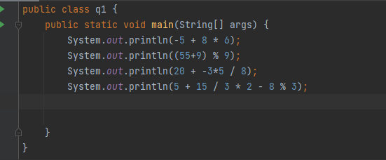

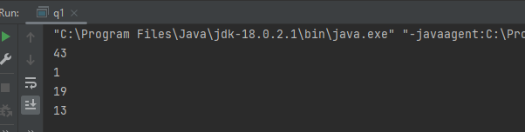

Question 3 )

Answers :

A : compiled

B : not Compiled bcz it has not string argument “String[] args” part

C : not Compiled bcz it has not main function “public static void main(String[] args) “

Question 4 )

Answers :

1. Missing the “void” keyword

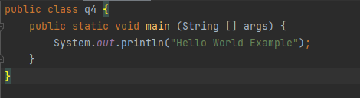

B ) because we cant divide number by 0

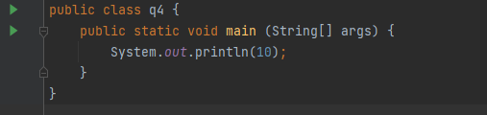

C ) not a error but need to write like

“Celsius 35 is Fahrenheit degree 95.0” to do that we need replace 9 by 9.0

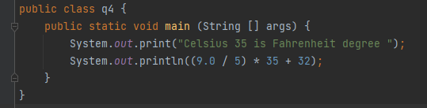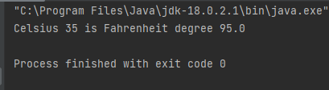

Question 5 )

Answers :

“productName” its String type Variable

“totalProducts” its integer type Variable , its also static (cant change the value after assigned)

“discount” its double type Variable

Question 6 )

need to change the ,

averageTemp , day1 , day2 datatypes to double

also need to correct mathematical expression like this

averageTemp = (day1 + day2 + (double)tempDay3 )/ 3;

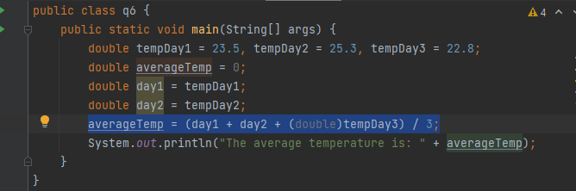

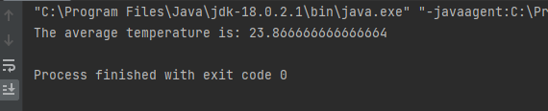

Question 7 )

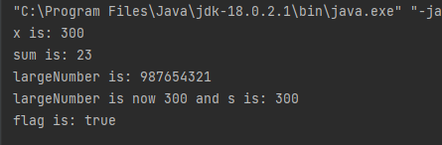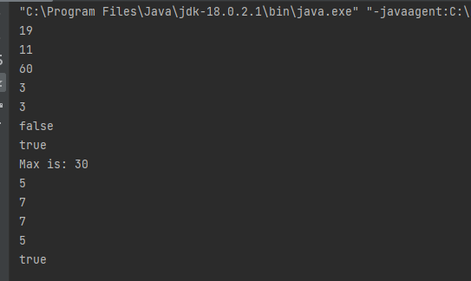

Question 8 )

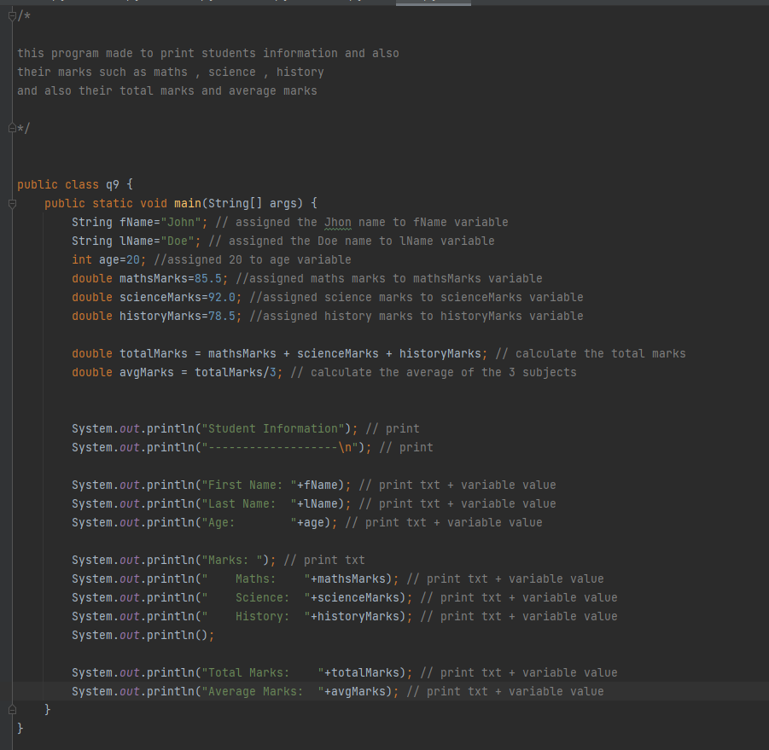

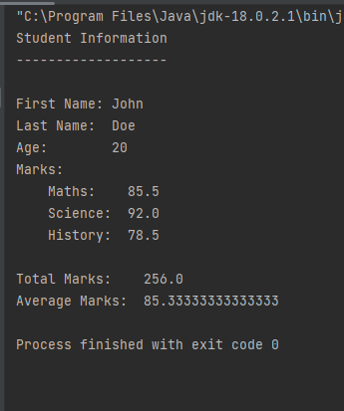

Question 9 )

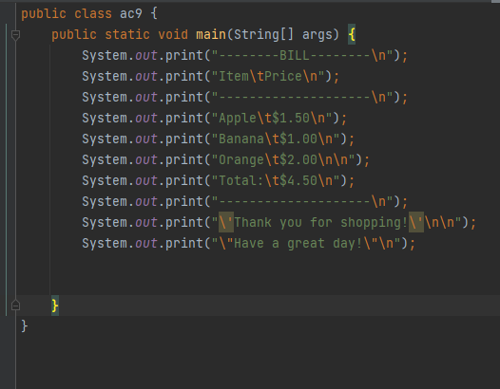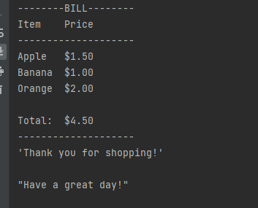

Question 10 )

